**CS 207: Applied Database Practicum**

**In-Class Activity 1: Introduction to HTML, CSS, and HTML5, 6th August, 2018**

In this activity, you will have to create a webpage similar to the one attached below.

1. Please create a HTML file and a CSS stylesheet for this webpage.

2. Download the image and video file form Moodle and store in the same folder as the HTML file and CSS stylesheet.

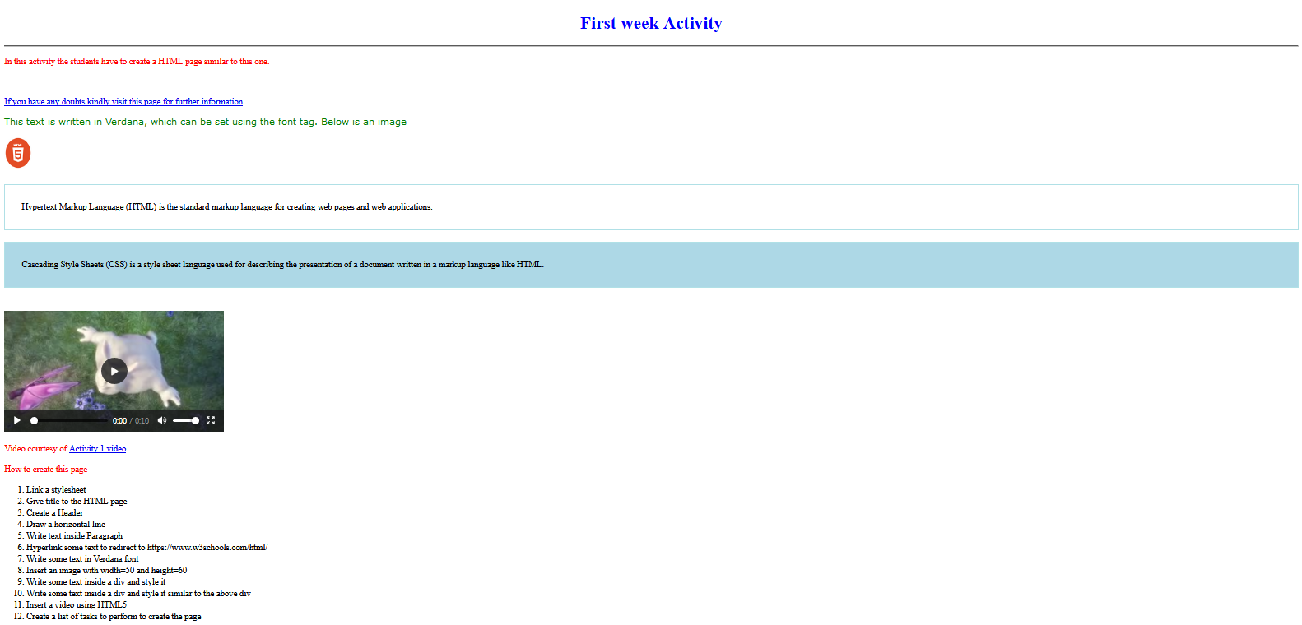

3. **Bonus:** ONLY if you have done the above steps, then you can try this bonus for an extra point.

Insert an youtube video using a iframe tag of width=420 and height=345 and src="https://www.youtube.com/watch?v=dQBzT3XBwzU&t=1s?autoplay=1"

